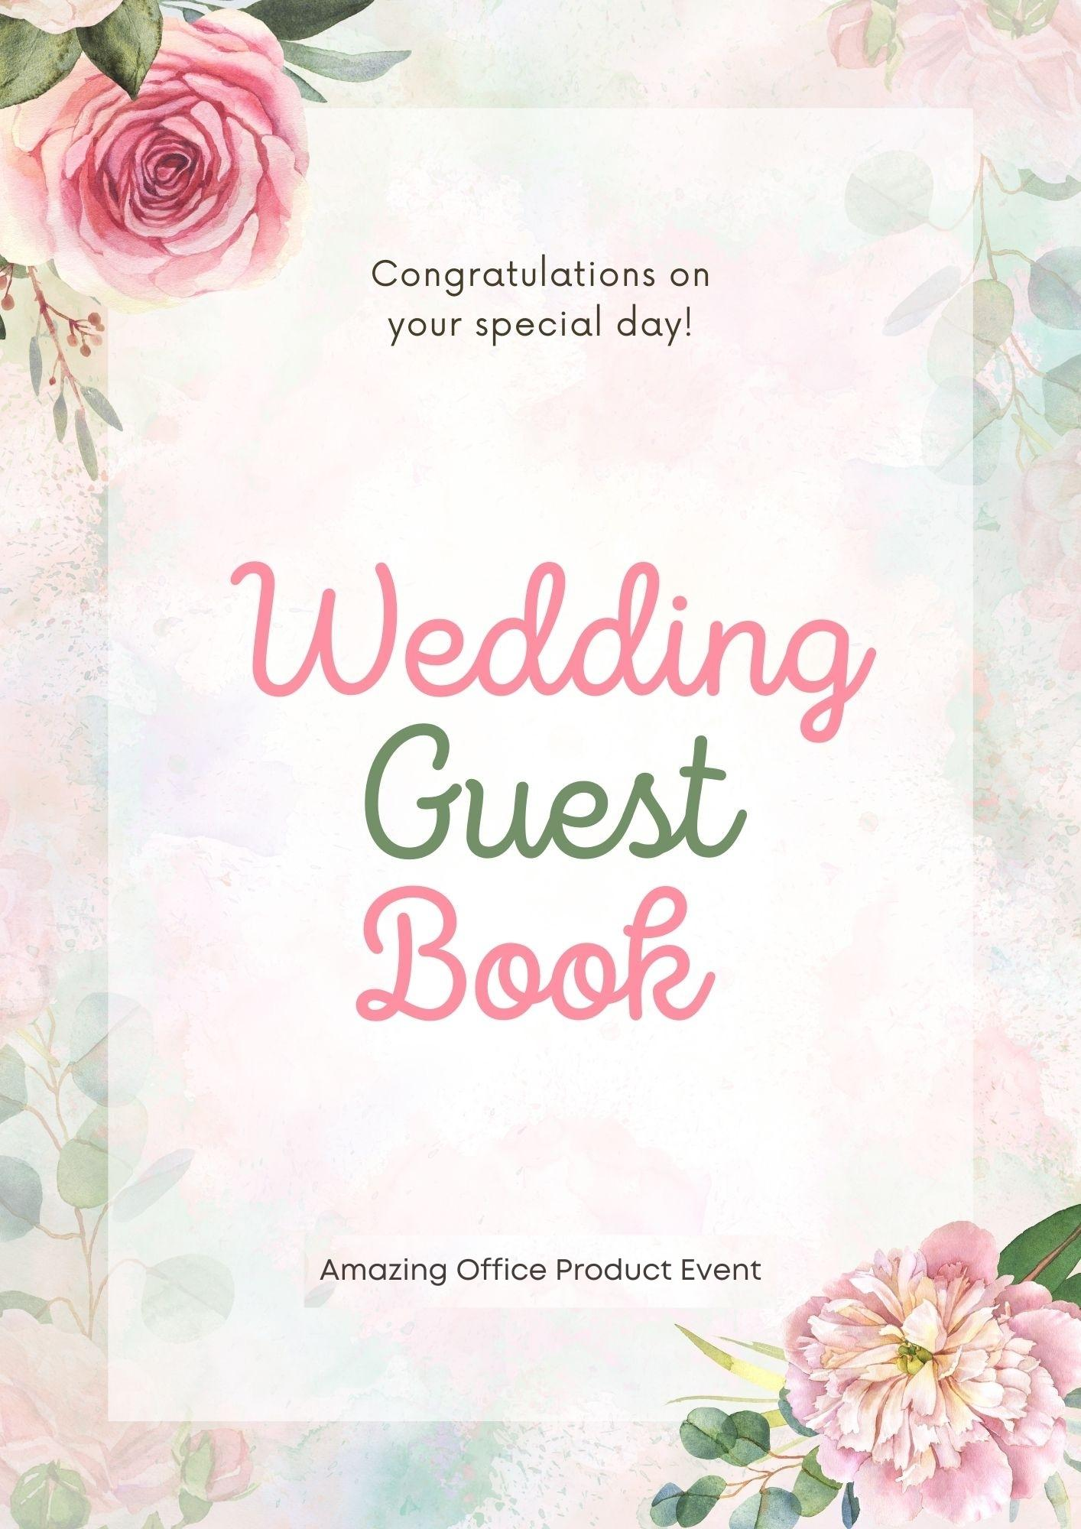

Wedding Guest Book

Amazing Office Product Event

DISCLAIMER

This eBook is geared towards providing reliable information regarding the “Wedding Guest Book.” There's an assumption that the publisher isn't obligated to provide accounting or other qualifying services since the eBook is being sold. If legal or professional advice is required, it should be sought from a practitioner in the field.
Reproduction, duplication, or transmission of any portion of this eBook, whether electronically or printed, is strictly prohibited. If you want to make a recording or save this work, you must have permission from the author. All rights reserved.
The information presented here is claimed to be accurate. The reader bears all responsibility for any inattention or misuse of any policies, methods, or instructions included in this piece of writing. In no event will the publisher be held liable or responsible for any compensation, damages, or monetary losses caused directly or indirectly by the information included.

Copyright © 2022 by Amazing Office Product Event
All rights reserved.

TABLE OF CONTENTS

INTRODUCTION 5
WHAT DO YOU NEED? 6
WEDDING GUEST BOOK: ADVANTAGES 8
CUSTOMER'S PERSPECTIVE 9
BEST GUEST BOOK 10
GUESTS' PHOTO ALBUM 11
CREATE A TRIBUTE WITH A GUEST BOOK 12
GUEST BOOK AT YOUR OFFICE 13
CONCLUSION 15

INTRODUCTION
Even decades after your wedding day has passed, you will pause, smile, and reflect on the events of the day. While feeling nostalgic, you may like to peruse your guest book. In other words, what can you do to elevate it to a whole new level?
Simply a camera and a little creativity are all that is required.
It's an excellent method to remember your special day. It's a hardback picture album filled with both wedding guests' Polaroid photos and their kind words to the newlyweds. Are you interested in knowing what you need to make your polaroid guest book? Don't worry, and this book is your best solution. It aims to tell you how to use a guest book and benefit from it.
No wedding is complete without a guest book; it's just as important as the cake and the guests.
To learn why and how it may help you and your customers, continue reading.
Let's start reading and explore all the aspects of wedding guest books.
Keep Reading…

WHAT DO YOU NEED?
You can easily and affordably create a Polaroid guest book for your event. To save money on your wedding reception decor, you don't have to acquire a lot of pricey equipment.
Let me present you a brief rundown of everything you'll need to begin:

Polaroid Camera & Film:
There should be at least two of these cameras on hand if your wedding is huge enough to warrant more than one. Packs of film for your visitors are also a good idea. Don't be surprised if your visitors make two or even three efforts at getting the perfect shot.
You never know when you may need it!

Guest Book:
It's important to have a guestbook. A hardcover guest book is a next thing you'll need.
As a keepsake, you'll want to get a high-quality bound book for this occasion.
A few additional pages should always be kept on hand if you run out of room in your guest book and need to include more.

Pencils & Markers:
Expect your visitors to bring their writing implements. Depending on your preference, you'll also need a few markers for attendees to sign their names in the guest book or on their Polaroid snapshot.
Black permanent ones provide a more vintage feel.

Double-Sided Tape:
Avoid using glue in your projects. Your guest book will thank you if you have a couple of rolls of double-sided tape on hand.

Hand Sanitizer:
It is a must-have. A hand sanitizer station is also recommended if visitors wish to disinfect their hands after handling the products or have markers on their hands.
It's best to use a nice dispenser instead of a giant container of hand sanitizer to avoid ruining the atmosphere.
Despite this, I've gone to several weddings without one, and I doubt that I'm the only one who has.
Then, you may have to put on your 'Subtle Sales' hat to remind them of the significance of a guest book.
You, on the other hand, are at a loss? For your benefit and that of your clients, we'll break it down and explain what to say so that you can both understand and communicate the necessity of a visitor signing book.
Keep Reading…

WEDDING GUEST BOOK: ADVANTAGES
Custom wedding guest book has many advantages. From the professional photographer's (vendor's) point of view, the advantages of a signing book are also different from the client's point of view (the end-user).
First, we'll talk about you and the benefits of selling a guestbook:

More Sales:
The obvious first: an additional selling point. You might think of it as an additional sale. If your price strategy has been executed correctly, this can only be beneficial in the long run.

Upselling Idea:
Guest books are great for upselling wedding packages or bundles since they're the right product to include in them. It may be used as a "loss-leader," a freebie, or a very low-priced add-on if you buy a certain package or number of products.
Pricing yourself appropriately is a certain way to make the money you're looking for in the end.

Brand Item:
Guest books are a great way to put your brand and show off your level of customer service.
Signing books like the one seen above may help you build your name recognition and set yourself apart from the competition. Traditional but frequently forgotten items can help make you seem more professional and comprehensive, which is a good thing.
Keep Reading…

CUSTOMER'S PERSPECTIVE
A signing book has several benefits for clients and end-users alike, so let's take a closer look.
You must know this as a professional photographer since it will help you better understand your customers and provide you with a means to remind them of its value if they forget.

Priceless Memento: For each newlywed couple
Even if there is a single solution, it is a thorny one. That intent is comparable to the record itself in that the guest book serves as a genuine, priceless souvenir.
Singing books may be overlooked as a needless investment since they seem to be nothing more than a collection of autographs. Yet, they remain the most useful methodology to recall all the people who attended the event.
If we're being honest, it's hard to picture every guest at most weddings, much alone every couple in attendance. But would such photographs want to be part of an album? Either that or a photo album the size of a college biology textbook would result in small photographs on each page. I won't even suggest an album that would be boring to listen to since it would have no narrative flow.
So, you're going to be telling me, "Yes, it is doable and simple to have every individual shot, and you don't even need them in the book! That is what the bonuses or a digital copy are for!" I know what you're thinking.
OK, but how many married people sit down 5 or 10 years after their marriage and say, "Hey, pull out the USB drive; I want to locate images of that guy I knew in high school."? You already know this, dude. I'm quite sure he was there.
Instead, collecting each guest/idea, couple's desires, and remarks is far more doable and significant. In this way, we arrive at the next stage.
Who says you have to sign your name on a book merely?

BEST GUEST BOOK
Guest Books don't have to be burdensome or costly.
My recommendation for a standout logo is both original and striking. Additionally, it must be beautiful, enticing, and made by hand.
In the case of a signing book, the Photo Book Pro is ideal. Check out the horizontally 12x8 format for a one-of-a-kind look.
You might also consider offering a little album as an alternative, which is even more rare and lovely.
In this scenario, you can also find a 10x10 in either our Creative or Exclusive Collections, both of which include a gorgeous portrait of the couple on the front cover. Consider the guest book a star in and of itself by embellishing it with metal corners, definitely looked edges, spacers, and embossed lettering.
Keep Reading…

GUESTS' PHOTO ALBUM
Another method to customize a wedding guest book is to add a few of your favorite wedding images.
If you occurred to photograph the couple during their engagement session, those photographs would make fantastic additions to their wedding book and would be the ideal option for inclusion.
Simply utilizing other pre-wedding photographs of the pair would be OK if you didn't obtain an engagement session.
The use of photographs may liven up a guest book that might otherwise be dreary and lifeless. Guests might even interact with the photographs by adding comments and making jokes about them. As long as you include a few photos and some blank pages, you'll have a unique wedding gift.
Keep Reading…

CREATE A TRIBUTE WITH A GUEST BOOK
You would be forgiven for thinking that a wedding signing book is unnecessary since there will be a large list of names. However, who said that wedding books had to be signed only?
Therefore, guest books should be a place where guests may express themselves in whatever way they want. Wishes and anecdotes that are meaningful and concise are all examples of this. Even a painting or photograph might be referred to as this.
Offering customers a book, particularly one with plenty of room, encourages people to write more than simply a signature and generic wishes. Couples may be more inclined to solicit longer contributions from their guests if they use a book with some breathing room.
There is no one-size-fits-all approach to encouraging visitors to leave a few comments. To be a "creative genius" for the couple's guests, you might offer inventive ways to leave notes for them as you capture their wedding celebrations.
However, even in the classic sense, visitors' words may be rather instructive. Think back to your senior yearbook in high school. Imagine the times you take it up and browse through the signatures and notice.
Keep Reading…

GUEST BOOK AT YOUR OFFICE
If your workplace has a steady stream of guests, you'll want a visitor's or guest book where they may sign in and out of their visit.
It may not appear like much, despite even a seemingly little change that may significantly impact your company's productivity and safety. Why don't we explain ourselves? This is why you need a visitor's or guest book in your workplace:

Protection Against Explosions & Fires
Workers and guests alike must be kept safe during a fire, and having a visitors' book may assist in that respect.
If the fire alarm sounds off and the building has to be evacuated, everyone who was meant to be in the building ought to be identified via a roll call.
This can be accomplished by keeping track of visitors' arrival and departure times. You can swiftly determine who belongs and who doesn't by having them sign in and out.
This will ensure that you are adhering to workplace fire safety requirements.

Keeping Track of All the Equipment
A guest book may help you keep track of who has borrowed what piece of your equipment, whether they are using it on-site or off-site.
After that, you'll be able to check off what each member of your team should have returned, ensuring that everything is in order.

Leaving Feedback on A Company's Website
Like hotels, some companies keep a guest book by the front desk or coffee table where clients may give feedback on the company's goods and services.
I like this since it's a terrific tool for consumers to provide feedback, and it looks nice when other people see it. No one will give a terrible comment like this in person; they'll keep it for internet review sites!

Improved Protection
Having a guest book may assist increase workplace safety in the same manner that it can help reduce the fire risk.
A list of everyone who is supposed to be in your office or building might help you immediately identify anybody who is not supposed to be there. Having this feature is particularly useful in bigger facilities where it's not always easy to tell whether or not a visitor is an employee.

Organizing & Referencing
A record of all your guests is a great way to keep track of who you've seen and at what time.
Planning future appointments or reporting on who you've talked to for job interviews, business meetings, or most anything else might benefit greatly from this information.
Keep Reading…

CONCLUSION
From the above talk, it is concluded that, as a picture album, a wedding guest book can serve as a treasured keepsake. As a picture book, the true worth may be difficult to see at first, but it becomes clearer as time passes and circumstances have changed.
There is no need to be arrogant or horrible when signing books. As a result, however, the memories they may bring are priceless, particularly when accompanied by an album and other souvenirs.
Your creativity is the only limit to creating a special guest book, but one thing is for sure: guest books are an essential part of any wedding and may help you grow your company. It may be time to give the guest book a second thought this year.

Thank You!

